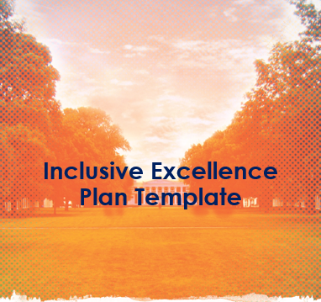
Description:
- The following template is the preferred format for the IE plan for your area.
- Utilizing a consistent format for all areas will help UVA to communicate its collective plans publicly, and to show clear alignment of all actions and measures to the IE framework and the University’s strategic plan.
- There is no set length that is expected for the narrative sections. Not all goals will require funding.
- Schools/Areas may have goals in all, some, or one of the dimensions based on the self-study and priority setting process. There are no set expectations for the number of goals your plan should include but should be reflective of what will actually be done and measured.

Introduction
What to include in this section:
- A brief overview of the IE plan in relation to the area’s mission and vision.
- A short description of the process used to develop the strategic IE plan.
Self-Assessment
What to include in this section:
- A set of reflections on the school/area’s current strengths, challenges, opportunities, and needs in relation to equity, inclusion, and diversity issues.
- Lessons learned from the study you engaged that have influenced your strategic IE planning process.
- Key findings for each of the IE framework dimensions that were engaged in the study.
Goals, Actions, Measures, and Implementation Plan
We recommend an IE plan for a 3-5 year period. Below is the preferred IE plan template:
Access + Success |  | 2030 Vision: Recruit and support exceptionally talented, diverse, and service-oriented students. Recruit, support, and retain excellent and diverse faculty and staff.
Goals/Objectives | Actions |  | Outcomes  (Data/Metric) | Timeframe(s) | Responsible  Office/Position | Funding/Resource  Allocation

Climate + Intergroup Relations |  | 2030 Vision: Continuously promote and strengthen an inclusive community of trust, a culture of integrity, mutual respect, excellence, collaboration, and innovation.
Goals/Objectives | Actions |  | Outcomes  (Data/Metric) | Timeframe(s) | Responsible  Office/Position | Funding/Resource  Allocation

Education + Scholarship |  | 2030 Vision: Enable faculty, staff, and students to work across traditional boundaries and prepare servant-leaders to shed new light on enduring and profound questions in our diverse community and globally connected world.
Goals/Objectives | Actions |  | Outcomes  (Data/Metric) | Timeframe(s) | Responsible  Office/Position | Funding/Resource  Allocation

Infrastructure + Investment |  | 2030 Vision: Be a community that consistently lives its values and ensure that our systems enable our students, faculty, and staff to do their best work.
Goals/Objectives | Actions |  | Outcomes  (Data/Metric) | Timeframe(s) | Responsible  Office/Position | Funding/Resource  Allocation

Community + Partnership |  | 2030 Vision: Be a strong partner with and good neighbor to our region, contributing to economic and social well- being by providing accessible healthcare, innovative education, opportunity, and engaging alumni.
Goals/Objectives | Actions |  | Outcomes  (Data/Metric) | Timeframe(s) | Responsible  Office/Position | Funding/Resource  Allocation

Communication Plan
What to include in this section:
- A brief overview of the ways in which you will communicate your IE plan, progress, and impacts to stakeholders, community partners, and others.
- Information on how people can stay up to date on and participate in the success of the IE plan.

